English Writing Long-Term Plan-Year 6

 | Autumn 1 | Autumn 2 | Spring 1 | Spring 2 | Summer 1 | Summer 2
Class Reader-Taken from reading spine | 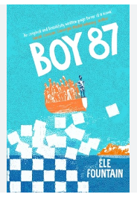 | 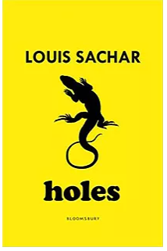 | 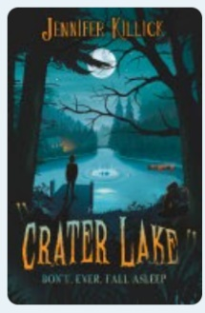 | 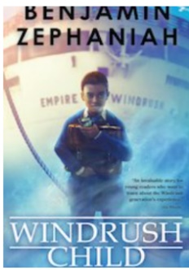 | 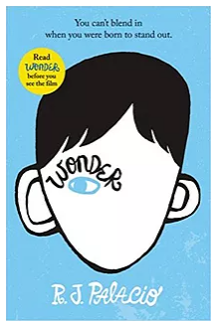 | 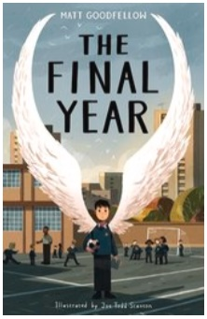
Writing units and outcome | Adventure narrative based on the Journey by Francesca Sana  Persuasive speech to encourage men to fight during WW2.  War poetry (publish) | Adventure narrative based on Kensuke’s Kingdom including a character description.  Newspaper report about the disappearance of Michael. | Perfect day recount in the form of a diary entry.  Information text about the discovery of a new creature.  Newspaper article reporting on the discovery of the new creature. | Short scary story writing unit.  The Arrival narrative writing unit. | Letter of complaint from one book character complaining about another book character.  Narrative unit based on the music video Titanium.  Recount based on Harry Potter receiving his first letter from Hogwarts. | Balanced argument.  Takeover day letter writing.  Poetry based on The Final Year.
Spelling-Following SCODE  -See National Curriculum Appendix  (Link below)  I can spell most words correctly (years 5 and 6) and use a dictionary to check the spelling of uncommon or more ambitious vocabulary. | SCODE  focus sound /sh/ coded sh, ch, ti, si, ssi, ci including curriculum words; shoulder, competition, dictionary, explanation, pronunciation, conscience, conscious, ancient, sufficient, appreciate, especially,  Hip homophones; stationary/stationery  Superb suffixes; ous, cian | SCODE  focus sound /ul/ coded -le, -al, -el, -il, ul including curriculum words; vehicle, muscle, vegetable, available, individual, symbol, prejudice,  Hip homophones; complement/compliment, principle/principal, bridle/bridal, angle/angel,  Word endings; able/ible,  Superb suffixes; al, -ful,  Powerful prefixes; ultra, mult | SCODE  code ough making the sounds /or/, /u(f)/, /oa/, including curriculum word; thorough  /ee/ coded ei, ie including curriculum words; achievement, mischievous  /i/ coded i, y, -y including curriculum words; privilege, individual, identity, immediate, critic, determined, bargain, symbol, system, physical, rhythm, dictionary, category, variety, opportunity, yacht | SCODE  focus sound /r/ coded r, rr, wr, rh including curriculum words; recognise, relevant, recommend, restaurant, frequent, hindrance, disastrous, programme, professional, privilege, prejudice, embarrass, rhyme, rhythm, committee  Hip homophones; past/passed, desert/dessert, guest/guessed  Words with ‘silent’ letters; /m/ coded mb, mn  Powerful prefixes; co, con | SCODE  word endings; ture/sure including curriculum words; temperature, signature, leisure, average  Hip homophones; weary/wary  Superb suffixes; -ly, -ally | SCODE  Double Bubble (double letters within words) including curriculum words; accommodate, accompany, according, attached, marvellous, suggest, sufficient, exaggerate, community, committee  Hip homophones; programme/program  Hyphen Academy including curriculum word; awkward  Powerful prefixes; self, ex, co
Vocabulary, Punctuation and Grammar | Teach:  Passive voice  Using semi colons and description detail colon sentences.  Dialogue to advance the action and for characterisation.  Select from a range of imaginative and ambitious vocabulary.  The difference between vocabulary typical of informal speech and vocabulary apprpriate for formal speech and writing. | Consolidate punctuation and grammar taught in years 3-6 and new year 6 teaching taught in Autumn 1.
Handwriting-Following Letter-join-see link below | REVISIT  Understand which letters are best left unjoined.  Develop the fluency of joined script. | REVISIT  Maintain handwriting with fluency.  Write legibly, fluently and with increasing speed. |  | Choose the writing instrument that is best suited for a task.  Maintain legibility in joined handwriting when writing at speed.
Composition and Effect  I can write for a range of purposes and audiences (stories, biography, autobiography, journalistic writing, argument, formal, impersonal writing and poetry).  Proof-read for spelling and punctuation errors. | Integrate dialogue in narrative to convey characters and advance the action.  Start sentences in different ways - REVISION (e.g. – ed verbs, - ing starters, similes, fronted adverbials to tell the reader how, when or where). | Describe settings and characters in narrative work.  Use a range of literary features to create effect-alliteration and onomatopoeia.  Use a range of devices to build cohesion (e.g. conjunctions, adverbials of time and place, pronouns, synonyms) within and across paragraphs.  Accurately adapt sentence structure and word order to a text type to sustain interest.  Layout devices. | Write a non-narrative using organisational devices appropriate to the text type.  Use a range of sentence openers-judging the impact for effect needed.  Develop ideas in creative and interesting ways. | Select interesting strategies to move a story forward (e.g. characterisation, dialogue with the audience, dialogue and negotiation within contexts). | Use different techniques to introduce and conclude work appropriately (e.g. I am writing to..., Dear Sir/Madam, opinion, summary and justification comment).
Taught terminology | Subject  Object  Synonym/antonym  active/Passive  Semi -colon  Dash  colon | Bullet points | Hyphen | Ellipsis

Spelling National Curriculum Appendix-https://assets.publishing.service.gov.uk/government/uploads/system/uploads/attachment_data/file/239784/English_Appendix_1_-_Spelling.pdf
Letter-join- https://www.letterjoin.co.uk/log-in.html

