English Writing Long-Term Plan-Year 5

 | Autumn 1 | Autumn 2 | Spring 1 | Spring 2 | Summer 1 | Summer 2
Class Reader-Taken from reading spine | 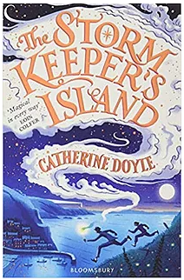 | 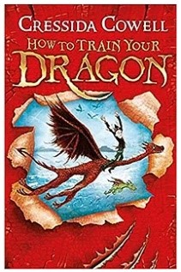 |  | 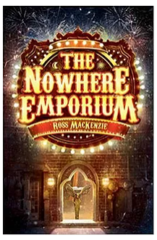 | 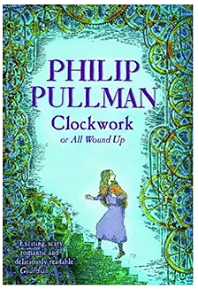 | 
Unit / Book | The promise character description and setting description.  Poetry free verse based on the Promise.  Persuasive letter to express their views on homework. | Leon and the place between – adventure narrative.  Leon and the place between newspaper report.  Information text on biomes. | Explanation text on mythical creatures – how to take care of the creature.  First- person narrative. | Frances Brandywine – suspenseful writing.  Balanced argument – should school days be shorter? | The day the war came – adventure narrative.  The day the war came – newspaper report. | Performance poetry.
Spelling-Following SCODE  -See National Curriculum Appendix  (Link below) | SCODE  focus sound /f/ coded f, ff, ph, gh including curriculum words; familiar, foreign, forty, frequently, profession, sacrifice, sufficient, physical.  Hip homophones; father/further, affect/effect, profit/prophet. | SCODE  words ending ent/ant (plus ence/ance) including curriculum words; equipment, government, development, excellent, environment, parliament, convenient, apparent, ancient, sufficient, relevant.  Hip homophones; complement/compliment.  Superb suffixes; ment  Powerful prefixes; ant | SCODE  words ending ency/ancy (plus ent/ant/ence/ance) including curriculum words; frequent, apparent, convenient, ancient, sufficient, existence, occurrence, convenience, hindrance, nuisance.  Hip homophones; effect/affect, aloud/allowed, heard/herd  Apostrophe Academy - Contractions including; contractions v’s pronouns. | SCODE  focus sound /s/ coded s, ss including curriculum words; sentence, suppose, special, strength, consider, correspond, recognise, curiosity, desperate, controversy, secretary, sacrifice, signature, sincere, nuisance, restaurant, especially, suggest, persuade, soldier, system, symbol, stomach, sufficient, aggressive, embarrass, necessary, harass, cemetery.  Hip homophones; past/passed, desert/dessert, guest/guessed. | SCODE  focus sound /s/ continued coded c, -se, -ce, sc including curriculum words; bruise, conscience, existence, convenience, hinderance, muscle, conscious, disastrous, marvellous, mischievous.  Hip homophones; cereal/serial, advice/advise, practice/practise, device/devise.  Superb suffixes; -ous | SCODE  focus sound /n/ coded n, nn, kn, gn including curriculum words; natural, naughty, notice, answer, necessary, neighbour, nuisance, language, guarantee, explanation, lightning, definite, determined, signature, bargain, interrupt, interfere.  Powerful prefixes; in, inter
Vocabulary, punctuation and Grammar | Use capital letters, full stops, question marks, exclamation marks to demarcate sentences.  Use relative clauses with who, which, where, why or whose.  Use commas to demarcate a relative clause in a sentence.  Use pronouns to avoid repetition.  I can link clauses in sentence using a range of subordinating and coordinating conjunctions. | Use relative clauses with who, which, where, why or whose.  Consistently Use capital letters, full stops, question marks, exclamation marks to demarcate sentences.  Accurately use commas to demarcate a relative clause in a sentence.  Use brackets, dashes and commas to indicate parenthesis.  Use inverted commas for direct speech and its associated punctuation | Use inverted commas for direct speech and its associated punctuation.  I can use more sophisticated conjunctions (for example, although, however, nevertheless).  Use brackets, dashes, ellipsis and commas to indicate parenthesis.  Link ideas across paragraphs using adverbials of time (e.g. later), place (e.g. nearby), number (e.g. secondly). | Use nouns, pronouns and tenses accurately and consistently throughout.  Indicate degrees of possibility using adverbs (for example, perhaps, surely).  Link ideas across paragraphs using tense choices (e.g. He had seen her before.) | Use commas to clarify meaning or avoid ambiguity in my writing.  Let’s eat Grandma. Let’s eat, Grandma.  Indicate degrees of possibility using modal verbs (for example, might, should, will, must). | Use all taught punctuation effectively.  Modal verbs (for example, might, should, will, must).
Handwriting-Following Letter-join-see link below | Use diagonal and horizontal strokes needed to join letters.  Understand which letters are best left unjoined. | Develop the fluency of joined script. | Maintain handwriting with fluency. |  |  | Write legibly, fluently and with increasing speed.
Composition and Effect  I can write for a range of purposes (myths, legends, stories, play-scripts, instructions, recounts, persuasive writing, letters, leaflets, articles, debates and poetry).  Proof-read for spelling and punctuation errors. | Write a non-narrative using organisational devices appropriate to the text type.  Use paragraphs with clear themes to organise writing.  Select appropriate vocabulary to enhance meaning.  Use a range of sentence openers -(e.g. – ed verbs, - ing starters, similes, fronted adverbials to tell the reader how, when or where)  I can add expanded noun phrases to make sentences more precise and detailed.  I can accurately adapt sentence structure to text type.  I can recognise vocabulary and structures that are appropriate for formal writing. | Write a narrative with a clear structure, setting, characters and plot.  Select interesting strategies to move a story forward (e.g. characterisation, dialogue with the audience, dialogue and negotiation within contexts). | Build cohesion within a paragraph (for example, then, after that)  Use a wider range of linguistic features.  Use a range of sentence openers – judging the impact or effect needed. | Use linguistic features to make writing more interesting-metaphors/simile/  Personification to make writing interesting.  Produce thoughtful and considered writing (uses simple explanation, opinion, justification and deduction).
Terminology | Relative pronoun  Relative clause  Parenthesis  Cohesion |  |  | Ambiguity | Bracket  Dashes  Modal verb

Spelling National Curriculum Appendix-https://assets.publishing.service.gov.uk/government/uploads/system/uploads/attachment_data/file/239784/English_Appendix_1_-_Spelling.pdf
Letter-join- https://www.letterjoin.co.uk/log-in.html

