English Writing Long-Term Plan-Year 4

 | Autumn 1 | Autumn 2 | Spring 1 | Spring 2 | Summer 1 | Summer 2
Class Reader-Taken from reading spine | 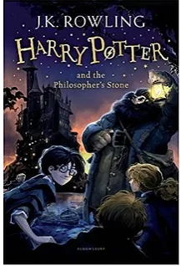 |  | 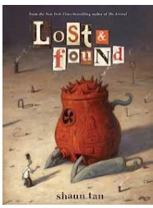 | 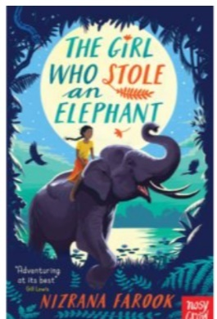 | 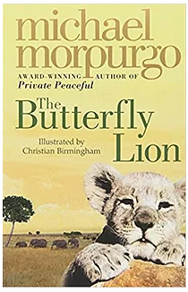 | 
Unit/Book | The Flood-Diary  Letter to Ferry Meadows  Harry Potter character description | BFG narrative  Setting description on Pompeii  States of matter non-chronological report | Diary of a Roman soldier  The Lost thing narrative – personification | Explanation text on the digestive system  Ning, nang, nong poetry unit. | Character description – Beowulf.  Letter of complaint between Grendel’s mother and the king. | Aladdin-Narrative-Write Stuff  Persuasive Advert – based on an item from Aladdin.
Spelling-Following SCODE  I can spell most words correctly (years 3 and 4)  -See National Curriculum Appendix  (Link below) | SCODE  focus sound /ee/ coded ea, ee, ie, ei, e, e_e including curriculum words; breathe, increase, believe, reign, recent, extreme, complete Hip homophones; meat/meet, week/weak, steal/steel, bean/been, piece/peace  Powerful prefixes; re and ad | SCODE  focus sound /g/ coded g, gu, gue, gh including curriculum words; grammar, group, guide, guard Hip homophones; grown/groan  focus sound /ai/ coded a_e, a, ai, ay, ey, eigh, ei including curriculum words; separate, favourite, famous, occasion, strange, potatoes, weight, eight, eighth, reign, straight Hip homophones; grate/great, stake/steak, mane/main, pain/pane, mail/male, sale/sail  Apostrophe Academy Contractions & Possession | SCODE  focus sound /l/ coded l, ll including curriculum words; length, learn, library, believe, island, particular, popular, regular, calendar.  Superb Suffixes; ly  focus sound /ar/ coded ar, a, al including curriculum words; heart, guard, separate, regular, peculiar, particular, grammar, popular, forward, calendar, February, library, ordinary, various, actual, answer, natural, imagine, material, favourite, famous, occasion, potato, strange | SCODE  focus sound /u/ coded u, o, ou including curriculum words; woman, purpose, enough, though, although, thought, through  Superb suffixes; -ous (including recap of -ed, -er, -ing & -est) | SCODE  Apostrophe Academy - Plurals, Irregular & Possession including curriculum words; potatoes, woman, women  focus sound /sh/ coded sh, ch, ti, si, ssi, ci including curriculum words; mention, position, occasion, occasionally, possession, special, question  Superb suffixes; -cian, -tion | SCODE  focus sound /k/ coded c, k, -ck, ch, que including curriculum words; continue, calendar, particular, complete, increase, consider, circle, describe, caught, peculiar, difficult
Vocabulary, Punctuation and Grammar | Correct use of capital letters and full stops to demarcate sentences.  Capital letters for proper nouns and the pronoun ‘I’.  Correct use of question mark.  Use expanded noun phrases.  Experiment with a wide range of punctuation-commas for listing | Use of a range of sentences (statement, command, exclamation, and questions) in writing and punctuate correctly.  Use fronted adverbials for when.  Experiment with a wide range of punctuation- commas after fronted adverbials.  Use apostrophes for contractions.  Use a wider range of conjunctions.  Use subordinate clauses to write complex sentences.  Use simple and complex sentences. | Experiment with a wide range of punctuation-  use commas to mark clauses.  Use fronted adverbials for where.  Use expanded noun phrases which include ‘with’ (the strict teacher with curly hair).  Use appropriate pronouns or nouns within and across sentences to aid cohesion and avoid repetition.  Use of inverted commas and other punctuation to indicate direct speech [e.g. a comma after the reporting clause; end punctuation within inverted commas] | Use fronted adverbials for how.  Use correct grammatical structures in sentences (nouns and verbs agree)  Use sophisticated conjunctions. | Use a range of fronted adverbials. | Use nouns, pronouns and tenses accurately and consistently throughout my writing.  Use a wide range of punctuation.  Use a variety of conjunctions.
Terminology | Determiner | Adverbial | Pronoun | Possessive pronoun
Handwriting-Following Letter-join-see link below | Ascenders and descenders are correctly formed. | Use diagonal and horizontal strokes needed to join letters.  Understand which letters are best left unjoined. | Maintain handwriting with fluency. | Increase legibility, consistency and quality of handwriting. |  | Write with consistent legibility and quality.
Composition and Effect  I can write for a range of purposes (stories, myths and legends, plays, recounts, newspaper reports, information texts, persuasive texts, explanation texts and poems)  Proof-read for spelling and punctuation errors. | Write a narrative with a clear structure, setting, characters and plot.  Write a non-narrative using organisational devices appropriate to the text type.  Plan writing to ensure clear, logical sequenced ideas.  Use paragraphs with clear themes to organise writing | Use linguistic features to make writing more interesting - similes. | Use linguistic features to make writing more interesting - personification. | Use linguistic features – plural and possessive apostrophe/s | Use a wider range of linguistic features to make writing more interesting - metaphors. | Use a wide range of linguistic features.

Spelling National Curriculum Appendix-https://assets.publishing.service.gov.uk/government/uploads/system/uploads/attachment_data/file/239784/English_Appendix_1_-_Spelling.pdf
Letter-join- https://www.letterjoin.co.uk/log-in.html

