 | Autumn 1 | Autumn 2 | Spring 1 | Spring 2 | Summer 1 | Summer 2
Class Reader-Taken from reading spine |  | 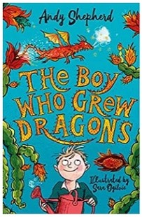 | 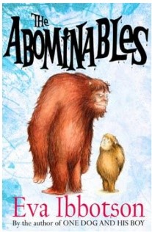 | 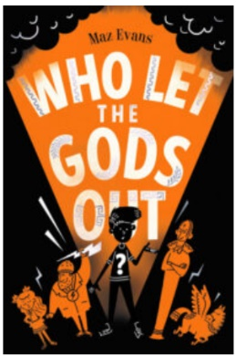 | 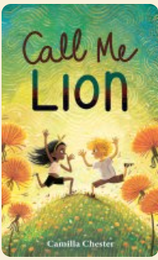 | 
Unit/Book | Own character creation and description inspired by Stardust.  Narrative inspired by Stardust. | Stone Age Boy narrative.  Information text on Flag Fen. | Underwater setting description based on the book Flotsam.  Postcard from the beach inspired by Flotsam. | Design own hero and mythical creature.  Use the hero and mythical creature creations to write their own myth / legend. | Adventure narrative based on the book ‘The secret of Black rock’  Persuasive letter to Mrs Anderson to convince her to not get rid of the school playground. | Narrative based on ‘the incredible book-eating boy’  Newspaper report based on the same book.
Spelling-Following SCODE | SCODE  focus sound /er/ coded ur, er, ir, ear, ar, our, or, re  including curriculum words; century, natural, surprise, purpose, answer, consider, exercise, different, certain, interest, perhaps, quarter, circle, heard, earth, early, learn, separate, regular, peculiar, particular, grammar, popular, forward, calendar, centre.  Superb suffixes; er & est  Hip homophones; weather/whether | SCODE  on focus sound /i/ coded i, y, -y including curriculum words; difficult, consider, possible, continue, interest, notice, experiment, position, imagine, accident, increase, history, minute, February, library, probably, ordinary, busy, business, build, fruit.  Hip homophones; links/lynx, sink/sync,  Superb Suffix; -ly  Powerful Prefixes; il, im, in, ir | SCODE  Apostrophe Academy – contractions  focus sound /ul/ coded -le, -al, -el, -il, ul including curriculum words; bicycle, circle, possible, accidental, actual, material, natural, occasional, difficult.  Superb Suffixes; -ful, -ly  Hip homophones; angle/angle, heel/heel/he’ll | SCODE  focus sound /s/ coded s, ss, c, -ce, -se, sc  including curriculum words; sentence, suppose, special, strength, consider, possess, possible, address, recent, centre, medicine, bicycle, accident, decide, circle, certain.  Hip homophones; mist/missed, accept/except, scene/seen  Powerful prefixes; dis & mis | SCODE  Suffix -ous including curriculum word; various.  Powerful prefixes; super & sub  Apostrophe Academy - Possession  word endings sure/ture | SCODE  focus sound /igh/ coded i_e, i, -y, igh, y including curriculum words; arrive, decide, describe, surprise, guide, opposite, medicine, favourite, promise, imagine, notice, library, bicycle, peculiar, material, island, height, eight.  Common confusions; quite/quiet
Vocabulary, punctuation and Grammar | Use full stops, capital letters accurately to demarcate sentences  I can use a capital letter for names of people, places, the days of the week, and the personal pronoun “I”  I can use a range of sentences (statement, command, exclamation and questions) in my writing and punctuate them properly.  I can use adverbs in my sentences. (e.g. then, next, soon, therefore),  I can use a range of sentences with more than one clause by using a wider range of conjunctions (see earlier years + re-teach when, if, although, because)  Use conjunctions to express time and cause (e.g. when, before, after, while, because, so ) | I can use question marks accurately  I can use a comma to mark an adverbial phrase.  I can use conjunctions to express time (after, when, before, next, while)  I can use past tense verbs correctly.  Use prepositions and conjunctions at the start of my sentences as well as in the middle (before, after, because of, during, in)  Analyse different text types before writing to understand structure, vocabulary and grammar.  Attempt to use direct speech correctly.  Use prepositions correctly.  I can use inverted commas to punctuate direct speech. | I can punctuate using apostrophes to mark contractions.  I can punctuate sentences using apostrophes to mark singular possession  I can vary the use of adjectives and adverbs to create a particular effect.  Use of the present perfect form of verbs instead of the simple past ( For example, He has gone out to play contrasted with He went out to play) | Forms of a and an e.g a rock, an open box | I can use a colon to introduce a list.  Use a range of sentences (statement, command, exclamation and questions) in my writing and punctuate them properly. | Use a range of sentences with more than one clause by using a wider range of conjunctions (see earlier years + re-teach when, if, although, because)
Handwriting-Following Letter-join-see link below | Ascenders and descenders are correctly formed. | Use the diagonal and horizontal strokes that are needed to join letters. | Understand which letters, when next to each other, are best left unjoined. | Increase the legibility, consistency and quality of handwriting. | Increase the legibility, consistency and quality of handwriting. | Increase the legibility, consistency and quality of handwriting
Composition and Effect  Write for a range of purposes.  Use a range of  punctuation for effect.  Plan writing by discussing and recording ideas.  Evaluate and edit my writing  Proof read for spelling and punctuation errors. | Write for a range of purposes.  Use a range of  punctuation for effect.  Plan writing by discussing and recording ideas.  Write a narrative with a clear structure, setting, characters and plot.  Group ideas into paragraphs accurately around a theme. | Write a non-narrative using simple organisational devices such as headings and sub-headings.  Use paragraphs to show the difference between different information and events. | Vary the structure of sentences. | Evaluate and edit my writing  Proof read for spelling and punctuation errors.
Terminology | Conjunction  Clause | Preposition  Prefix  Suffix  Direct speech  Inverted comma  Subordinate clauses |  | Consonant  Vowel

