 | Autumn 1 | Autumn 2 | Spring 1 | Spring 2 | Summer 1 | Summer 2
Class Reader-Taken from reading spine | 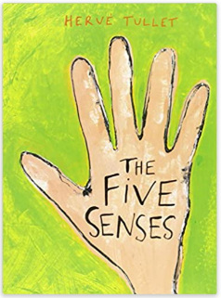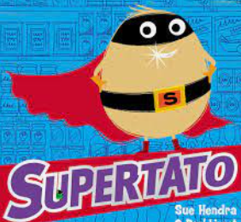 | 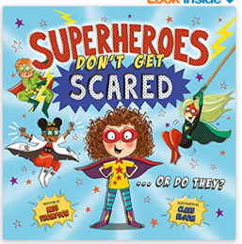  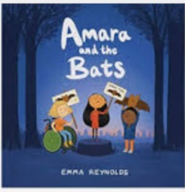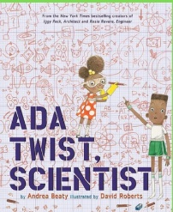 | 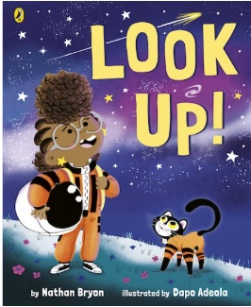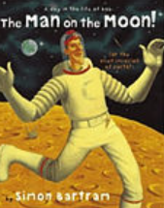  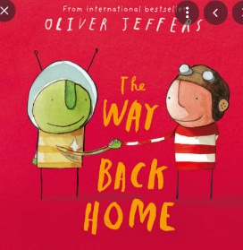 | 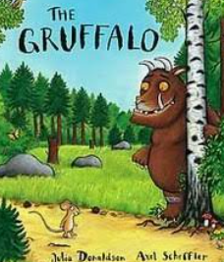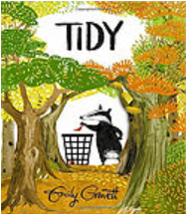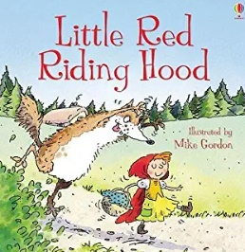 |  | 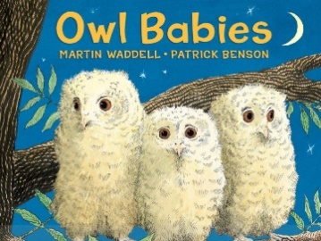  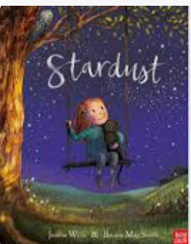
Unit/Book | Poetry-Voice 21  Stories based on the senses/superheroes  Narrative- Naughty Bus, noticing and touch  Stories with familiar settings/predictable patterned language  Narrative- Supertato sounds and actions  Non-fiction- taste (Supetato Veggies Assemble)  Stories with familiar settings/predictable patterned language  Narrative- Traction Man  Stories with familiar settings/predictable patterned language | The Leaf Thief- Setting description  Busy People- Police- Recount of visit from Police  Letter to Police  Firefighters  Instructions | The Man on the Moon- Diary  Aliens love underpants- Own character- description  Stories about fantasy words  Gruffalo  Character/setting description | Little Red Riding Hood- Retell/change the characters.  Traditional and  Fairytales  Recount- Visit to Fineshade | From my window- setting description  We’re roaming in the rainforest- Poetry.  Postcard | The Tiger who came to Tea – Narrative- story  Stories with familiar settings/predictable patterned language  Invitation  Recount- Trip to Hammerton  How to make a jam sandwich  Instructions
Spelling-Following NC objectives | Use simple phonics spellings strategies when spelling unknown words  To spell tricky words correctly (relevant to phonics phase)  Spell words containing phonemes that have been taught (relevant to phonics level) | To spell common exception words correctly (relevant to phonics phase)  Spell words containing phonemes that have been taught (relevant to phonics level)  Naming the letters of the alphabet | Spell the days of the week  Spelling rules for adding s and es | Using the prefix un, using ing, ed, er and s on the spelling of a root word. | To spell all tricky words correctly  To spell all common exception words correctly  Spell words containing each of the 40+ phonemes already taught  Using letter names to distinguish between alternative spellings of the same sounds | Write from memory a sentence dictated by a teacher using GPC’s and common exception words taught so far.
Vocabulary, Punctuation and Grammar | Write some sentences punctuated with capital letters and full stops.  Name the letters of the alphabet | Use adjectives and verbs  Add prefixes and suffixes (un/ing, ed, er, est) | Use ‘and’ to join independent clauses, word classes (noun to noun, verb to verb)  Use some time openers  Use capital letters for people, places and days of the week. |  | Begin to use exclamation marks  Begin to use question marks  Use capital letters for people, places and days of the week. | Demarcate most sentences with capital letters and full stops.  Use conjunctions: and, but, so, because  Use a comma between two adjectives
Handwriting-Following Letter-join-see link below | Use ascenders and descenders.  Form the letters using the correct sequence of movement.  Form capital letters and numbers 0-9 correctly. |  | Form lower case letters in the correct direction |  | Form lower case letters in the correct size relevant to one another. | Form lower case letters in the correct size relevant to one another.
Composition and Effect | Read back my writing to myself. | Write some demarcated sentences that have been orally rehearsed. | Read my sentences aloud.  Sequence at least 6 sentences to form a short narrative. | Re-read what I have written to check it makes sense.  Write for a range of purposes (fiction and non-fiction, poetry) | Sustain a narrative and non-narrative (writing at length, staying on task) | Re-read my writing to others.
Terminology | Letter, capital letter, word  Punctuation full stop | Sentence | Singular, plural, |  | Question mark, Exclamation mark

