RSE Curriculum
For Summer 2, our children will be looking at the Relationship and Sex Education curriculum in their Jigsaw lessons.
This unit will cover relationships and health at an appropriate level for each of our year groups. In the images below, the sex education content in outlined in red text. The health and relationships elements are in black text.
Parents may choose to remove their child from the Sex Education (red text) parts of the curriculum only. The health and relationships content is all statutory and children cannot be removed from this.
Following current governemnt guidelines, if you wish to remove your child from the sex education content, please complete the microsoft form attached to detail which part you wish to remove from and you will be contacted to arrange a meeting with Mrs Anderson to discuss this. If you have multiple children you wish to remove, a separate form will need to be completed for each child. If you do not wish to remove your child, then you do not need to complete the form.
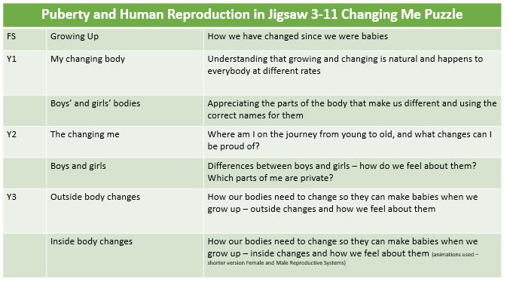
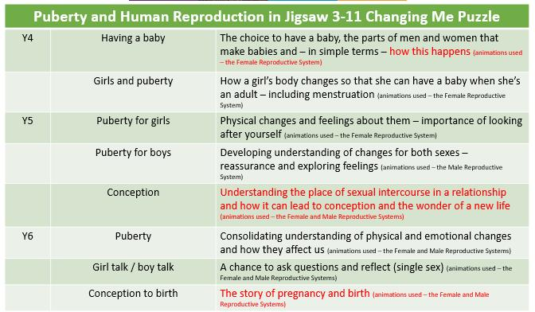
RSE Removal Form – Fill out form

